Git For Teams

Add all files to the staging area of your repository
$ git add –all

Verify the hidden repository folder was added:
$ ls –al

If you see a new hidden folder, .git, your repository has been created. This folder will contain the record of all the changes to your repository. There’s nothing scary contained in this folder, but if you remove it, your project will no longer be tracked. This means you will not be able to recover previous versions of any of the files in your repository, you will lose all commit messages for your repository, and whatever state the files are currently in will be immutable.

Reviewing History

Of course, the history of your project is a combination of the work you have done, as well as the work done by others you have collaborated with. To review the changes that have been made in a repository, use the command log

The command log will output a full history of your repository’s commit messages in
reverse chronological order.

$ git branch --list
A list of the local branches will be printed

To list all branches in your repository, use the parameter –all
$ git branch –all

To get a usable list of the names of the remote branches, use the parameter --remotes (or -r for short) instead
$ git branch –remotes

The list of remote branches does not stay up to date automatically, so the list will become out of date over time. To update the list, use the command fetch
$ git fetch

If, however, you have a lot of files you need to add, and they’re all contained in the same directory, you may want to use a wildcard to match files with a subdirectory (Example 5-17), or that all have a similar name (Example 5-18).

Example 5-17. Add all files, recursively, from a given path
$ git add <directory_name>/*

Example 5-18. Add all files with the file extension .svg
$ git add *.svg

You can also completely omit the filenames, and instead stage files according to whether or not they are known to Git. By using the parameter --update you can stage all files that are known to Git, and that have been edited (or updated) since the last commit:
$ git add –update

If you want to be even more outrageous, you can stage all changed files in the working directory by adding the parameter --all. This will restage any files that have been modified since they were first staged (ensuring all new edits are captured in the commit); stage any files that are known to Git, but not already staged; and stage any files that are not currently being tracked by Git. It is a very greedy command! Before using it, you should check the list of files that will be added

If you want even more granularity over your commits, you can choose to add partial changes within a saved file by using the parameter --patch. One of my favorite reasons for committing files in this way is to record several unrelated edits into multiple smaller commits.

Adding files via the --patch process is a multistep approach

Removing a File from the Stage

Removing a file from the stage doesn’t mean you’ll be undoing the edits you’ve made; it notifies Git that you’re not ready for these changes to be committed to the repository yet.

$ git reset HEAD ch05.asciidoc

Working with the Default Editor, Vim
By default, the commit editor is Vim. This works for me because I like Vim, but if you
don’t, there’s information on changing the editor in Appendix C. You’ll need a few key
commands to navigate Vim:
- i takes you from visual mode to insert mode. You’ll need to do this so that you
can begin typing your commit message.
- esc returns you to visual mode. From here you can navigate using the arrow keys
to a different line.
- :w saves the file by writing it to disk.
- :q quits the editor, returning you back to the command line.

You can also chain these commands together. For example, after writing your commit
message, you can save and quit the editor with esc :wq.

If you want even more details about the commit object, you can use the command show (Example 5-24) to list the changes that happened in that commit as text (of course, this will be less useful for binary files, such as images).

a new tag, import, is created for the commit hash fa04c30.
$ git tag import fa04c30

You can now list the available tags by using the command tag without any parameters
$ git tag

Connecting to Remote Repositories

In a centralized version control system, like Subversion, there is one master copy of
the repository and all work is written into that copy. When you commit, the information is immediately uploaded to that central repository and available to others. In a decentralized version control system, like Git, there is no single repository that everyone works with. It is merely a convention that declares one copy of the repository to be privileged (and considered to be the official source for the code).

mkdir my-git-for-teams
cd my-git-for-teams
git init
touch README.md
git add README.md
git commit -m "first commit"
git remote add origin git@gitlab.com:emmajane/my-git-for-teams.git
git push -u origin master

This will upload your branch and set it up for future use. Now whenever you are using this branch, you can issue the much shorter command git push to upload your work. By setting the upstream connection, you are building a relationship between your local copy of the branch and the remote repository. This has the same effect as when you used --track to check out a remote branch, except in that case you were starting with the remote copy and adding a tracked local copy.

Basic shell commands
cd ~ Change to your home directory
mkdir Make a new directory
cd directory_name Change to a specified directory
ls -a List hidden files for OS X and Linux-based systems
dir List files on Windows
touch file_name Create a new, empty file with the specified name

Basic Git commands

git clone URL Download a copy of a remote repository
git init Convert the current directory into a new Git repository
git status Get a status report for your repository
git add --all Add all changed and new files to the staging area of your repository
git commit -m "message" Commit all staged files to your repository
git log Review a repository’s history
git log --oneline View a condensed history of your project
git branch --list List all local branches
git branch --all List local and remote branches
git branch --remotes List all remote branches
git checkout --track remote_name/branch Create a copy of a remote branch for local use
git checkout branch Switch to a different local branch
git checkout -b branch branch_parent Create a new branch from a specified branch
git add filename(s) Stage only the specified file so that it is ready to be committed
git add --patch filename Stage only portions of a file so that they are ready to be committed
git reset HEAD filename Remove proposed file changes from the staging area
git commit --amend Update the previous commit with changes currently staged, and supply a
new commit message
git show commit Log details for a single commit
git tag tag commit Add a tag to a commit object
git tag List all tags
git show tag Log details for the commit where the tag was applied
git remote add remote_name URL Create a new reference to a new remote repository
git push Upload changes for the current branch to a remote repository
git remote --verbose List the fetch and push URLs for all available remotes
git push --set-upstream remote_name branch_local branch_remote
Push a copy of your local branch to the remote server
git merge branch Incorporate the commits currently stored in another branch into the current
one
git push --delete remote_name branch_remote
Remove named branch from the remote server

It’s very difficult to completely remove work from a repository in Git; it is,
however, relatively easy to lose work and not be able to find it again.

There are a lot of ways to undo work in Git, and each method is exactly right some of
the time. In order to choose the correct method, you need to know exactly what you
want to change—and how it should be different after you are finished

Figure 6-1 shows the three concepts you need to be aware of: the working directory (the files currently visible on your filesystem); the staging area (the index of changes that will be written to the repository after the next commit); and the repository (which stores files and records the changes made to the files over time).

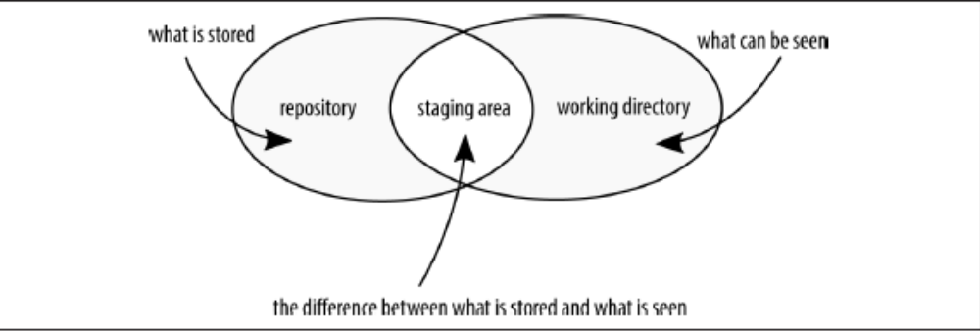

Figure 6-1. The working directory, staging area, and repository each contain different
information about your files

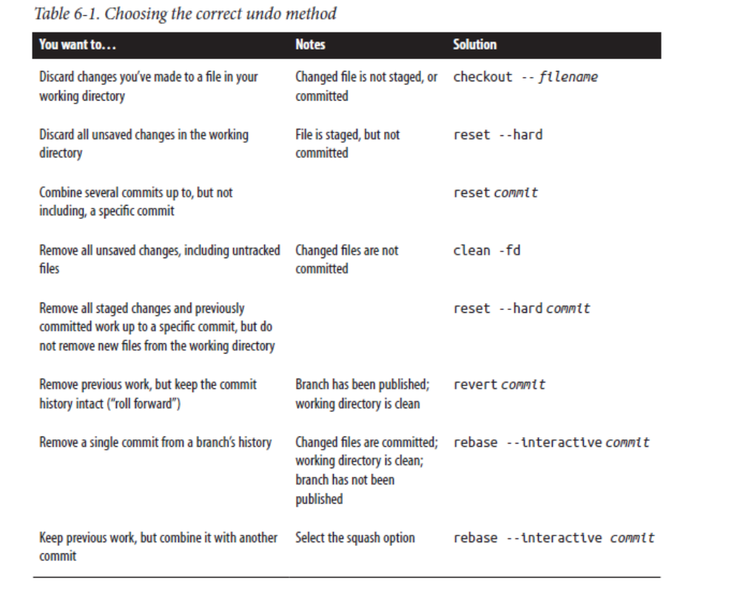
Figure 6-2 shows one diagram for the first scenario. Additional answers are available
on the Git for Teams website.

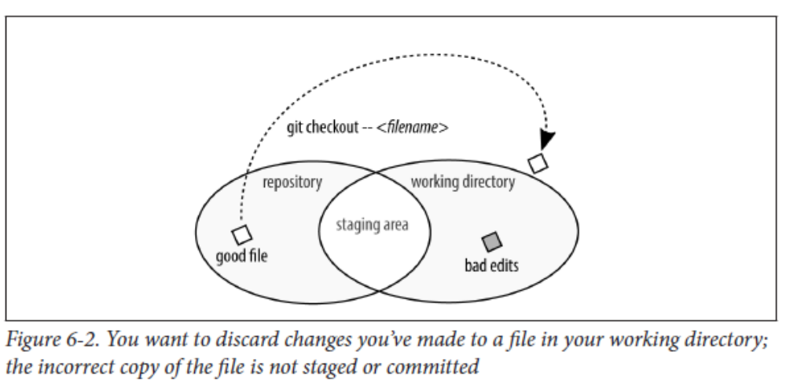
Diagram 6.2: command should be: git checkout HEAD -- filename

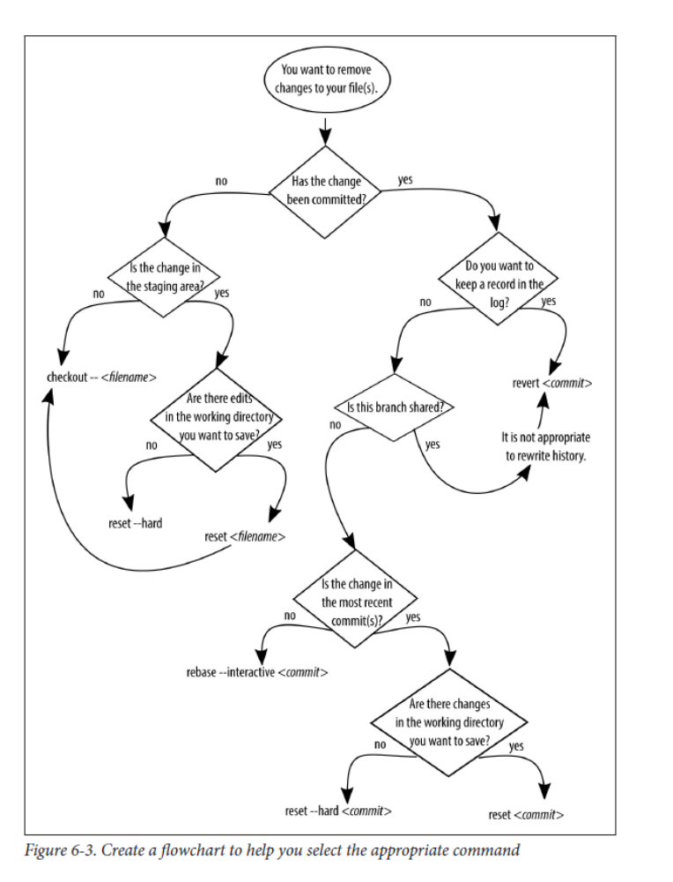

When you merge
the two branches, you can optionally combine all of those commits into a single one
at the time of the merge with the parameter --squash. If you use this parameter, you
will still need to run the command commit separately to save the changes from the
other branch. By merging the branch in this way, you will be unable to unmerge the
branch later. As such, it’s appropriate to use --squash only when merging branches
you wish had never been separate to begin with.

$ git checkout master
$ git merge experimental_idea –squash
$ git commit
$ git branch --delete experimental_idea

The command log displays commits that have been made to a particular branch; the command reflog lists a history of everything that has happened in your local copy of the repository. This means that if you are working with a repository you cloned from a
remote server, the reflog history will begin at the point where you cloned the repository to your local environment—whereas the log history will display all of the commit messages since the command init was used to create the repository.

$ git checkout working_branch
$ git merge restoring_old_commit
With the merge complete, you should now tidy up your local repository by deleting
the temporary branch:
$ git branch --delete restoring_old_commit
If you have published the temporary branch and wish to delete it from the remote
repository, you will need to do that explicitly:
$ git push --delete restoring_old_commit

The optional parameter -x appends a line to the commit message letting you know this commit was cherry-picked from somewhere else, as opposed to having been originally created on this branch at this point in history. This addition makes it easier to identify the commit later
$ git cherry-pick -x commit

Finally, if you decide you don’t want to keep the recovered work, you can obliterate
the changes:
$ git reset --merge ORIG_HEAD

Restoring Files

$ rm README.md
$ git status
$ git checkout -- README.md

The status message explains how to reverse the changes and recover your deleted file

If you have already staged the file, you will need to unstage it by using the command reset.
$ rm README.md
$ git add README.md
$ git status
$ git reset HEAD README.md

Working with Commits

A commit is a snapshot within your repository that contains the state of all of the files at that point in time. Each of these commits can be manipulated within your history. You can remove the commit entirely with the command reset, you can reverse theeffects of a commit (but maintain it in your history) with the command revert, and
you can change the order of the commits with the command rebase. Altering the history of your repository is a big no-no if you’ve already published the commits. This is because even the slightest change will result in a new commit SHA being stored in the repository—even if the code itself is exactly the same at the tip of the branch. This is because Git assumes that all new commit IDs contain new information that must be incorporated, regardless of the contents of the files stored in those commits.In this section, it is assumed you are working with commits that have not been shared with others yet (i.e., you haven’t pushed your branch)

Amending Commits
If you realize a commit you’ve just made is just missing one little fix, you can amend the commit to include additional files, or update the message that was used for the commit.

If you want to amend more than just the previous commit, though, you will need to
use either reset or rebase.

Combining Commits with Reset
it’s best to only use reset to alter the history of branches that are not shared with others (this means you created the branch locally, and you haven’t pushed it to the server yet).

If you want to discard the content contained in the commit objects you removed, you need to use reset with the mode hard. This mode is enabled by using the parameter --hard. When you use the mode hard, the commit objects will be removed, and the working directory will be updated so that all content stored in those commit objects are also removed. If you do not use --hard when you reset your work, Git keeps the content of the working directory the same, but throws away the commit objects back to the reference point. It will be as if you typed all of the changes from the previous commits into one giant piece of work. It’s now waiting to be added and committed.

The command reset resets the tip of the branch to the specified commit

For this operation to work, you need to be compressing consecutive commits leading up to your most recent commit. What we are doing is essentially a stepping stone to interactive rebasing. With this use of reset you will be limited to the most recent commits. With rebasing, you will be able to select any range of commits.

Unmerging a Branch

Ideally, you will notice you have incorrectly merged a branch immediately after doing
it. This is the easiest scenario to reverse. Git knows some of its commands are more dangerous than others, so it stores a pointer to the most recent commit right before it performs the dangerous maneuver. Git considers a merge to be dangerous, and so you can easily undo a merge right after it occurs by running reset, and pointing the tip of your branch back to the commit right before the merge took place:

$ git reset --merge ORIG_HEAD

Unmerging a Shared Branch

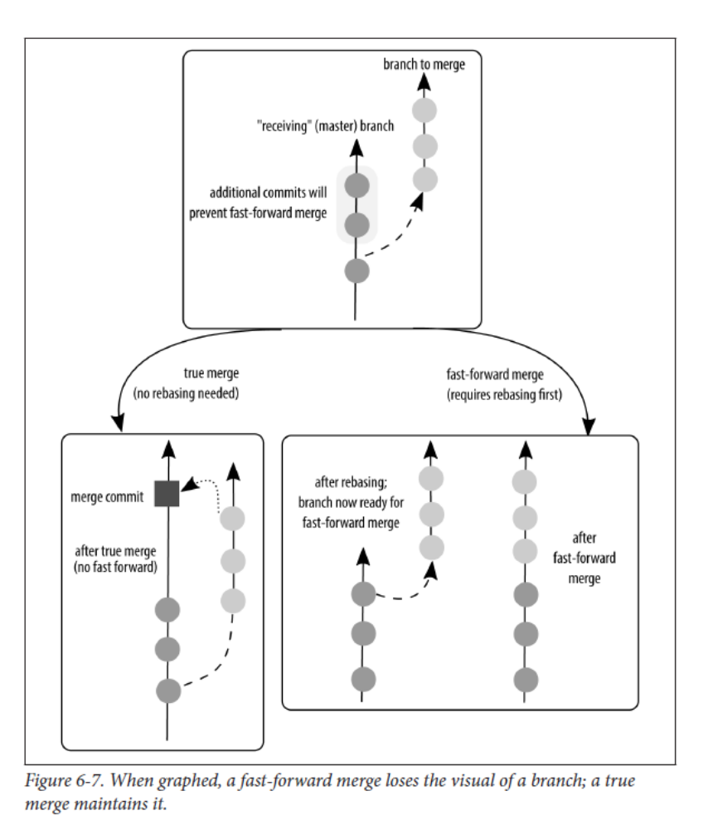
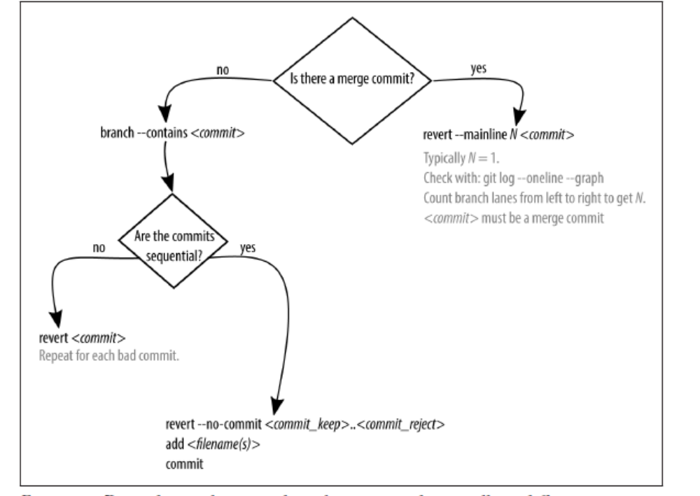

Figure 6-8. Depending on how your branch was merged, you will use different commands
to unmerge the shared branch

If the commits you need to revert are sequential, you’re in luck! The command
revert can accept a single commit, or a series of commits. Remember, though, that a
revert is going to make a new commit for each commit it is reversing. This could get
very noisy in your commit history, so instead of reversing each commit individually,
you can group them into a single reversal by opting to save your commit message to
the very end:

$ git revert --no-commit last_commit_to_keep..newest_commit_to_reject

After running this command you will end up with a dirty working directory with all
of the files reverted back. Review the changes. Then, complete the revert process:

$ git revert --continue

Table 6-2. Git commands for undoing work
Command Use
git checkout -b branch
Create a new branch with the name branch
git add filename(s)
Stage files in preparation for committing them to the repository
git commit
Save the staged changes to the repository
git checkout branch
Switch to the specified branch
git merge branch
Incorporate the commits from the branch branch into the current branch
git branch --delete Remove a local branch
git branch -D
Remove a local branch whose commits are not incorporated elsewhere
git clone URL
Create a local copy of a remote repository
git log Read the commit history for this branch
git reflog Read the extended history for this branch
git checkout commit Check out a specific commit; puts you into a detached HEAD state
git cherry-pick commit Copy a commit from one branch to another
git reset --merge ORIG_HEAD Remove from the current branch all commits applied during a recent
merge
git checkout -- filename Restore a file that was changed, but has not yet been committed
git reset HEAD filename Unstage a file that is currently staged so that its changes are not saved
during the next commit
git reset --hard HEAD Restore all changed files to the previously stored state
git reset commit Unstage all of the changes that were previously committed up to the
commit right before this point
git rebase --interactive commit Edit, or squash commits since commit
git rebase --continue After resolving a merge conflict, continue with the rebasing process
git revert commit Unapply changes stored in the identified commit; this creates a sharingfriendly
reversal of history
git log --oneline --graph Display the graphed history for this branch
git revert --mainline 1 commit Reverse a merge commit
git branch --contains commit List all branches that contain a specific commit object
git revert --no-commit last_com
mit_to_keep..newest_com
mit_to_reject
Reverse a group of commits in a single commit, instead of creating an
object for every commit that is being undone
git filter-branch Remove files from your repository permanently
git reflog expire Forget about extended history, and use only the stored commit
messages

Reset: Moves the tip of your branch to a previous commit. This command does not
require a commit message and it may return a dirty working directory if the
parameter --hard is not used.
Rebase:
Allows you to alter the way the commits are stored in the history of a branch.
Commonly used to squash multiple commits into a single commit to clean up a
branch; and to bring a branch up-to-date with another.
Revert:
Reverses the changes made in a particular commit on a branch that has been
shared with others. This command is paired with a commit and it returns a clean
working directory.

$ git checkout --track origin/video-lessons
$ git checkout --track -b video-lessons origin/video-lessons

Remove a remote connection
$ git remote remove nickname

you can now upload your local copy of the repository to the remote server
$ git push --all nickname

To upload a local name under a new name on the remote server, use the following
syntax:
$ git push nickname branch_local:branch_remote

For example, if you wanted to upload your branch main to the remote repository offi
cial and rename it to master in the remote repository, you would use the following
command:

$ git push official main:master

To update your local copy of the repository, first you would need to fetch the latest
changes to The Project
$ git fetch –all

Get a list of all branches in your repository
$ git branch –all

To see a history of the changes that have been added to the repository on the branch master, you can use the command log:

$ git log personal/master

To compare your local copy of a branch to what was just downloaded, you can add the parameter --patch to see the per-commit changes, or use the command diff to see a summary of all changes:

$ git log --patch personal/master
$ git diff master personal/master

If you prefer to check out the code base as a whole, you can check out the branch tip:
$ git checkout personal/master

This will put you into a detached HEAD state. To return to the local copy of the master branch, check it out:
$ git checkout master

$ git remote add personal https://gitlab.com/emmajane/gitforteams.git
To avoid confusion, I might also choose to rename the nickname for The Project remote from origin to official:

$ git remote rename origin official

These nicknames are completely arbitrary and are personal to your system. They will not be shared with others, so use whatever names make sense to you. Generally the convention is to use origin for the remote copy that most closely resembles your local work, and upstream for the copy of the repository that has the most new features being added by other developers that you might want to incorporate into your
own work.

Example 7-9. Copy a remote branch into your local repository
$ git checkout --tracking remote_nickname/branch

Example 7-10. Examine a remote branch without creating a working copy
$ git log --oneline remote_nickname/branch
$ git diff current_branch...remote_nickname/branch

Before merging the new work into your project branch, you will need to first ensure
all branches are up to date. This is necessary because Git won’t allow you to push
your copy of a remote repository if the destination branch (on the remote) contains
commits which are not in your local copy.

When uploading new work to a remote server, Git will only accept work as a fast forward merge. This means you don’t have to worry about having a merge conflict when
you push your work. Because of this restriction, your local branch needs to contain
all of the remote commits before you can push your branch. To update your work,
you will need to use the command pull to retrieve the changes from the remote
server and incorporate any new work into your local branches.

Git will add three lines into any file that has lines with conflicting information at
exactly the same point:

<<<<<<<
=======
>>>>>>>

This represents the our code, and their code separated by a dividing row of =. To
resolve a conflict you will need to edit the files, select the appropriate content to keep, and remove the markers.

If, before starting the merge, you know without a doubt that you will always want to
use either the incoming work (theirs) or your own work (ours), you can preemptively
instruct Git on how you want to address the proposed changes from the two branches. For example, if you wanted to merge in a branch that you knew contained fixes for the problem you were having, you could force Git to use the other branch when making its updates to your own branch:

$ git checkout branch_to_update
$ git merge --strategy-option=theirs incoming_branch

Depending on whether or not I wanted to keep the changes, I would merge the work in one of three ways: combine all work, overwrite their work with mine, or overwrite
my work with theirs.

- To combine all work (true merge):
$ git merge origin/master
- To keep my own work:
$ git merge -X ours origin/master
- To discard my own work in favor of the reviewer’s:
$ git merge -X theirs origin/master

To publish a new branch to GitHub, you will need to explicitly tell Git which remote you want to use as the upstream for your branch (Example 10-2).
Example 10-2. Set the upstream branch for a remote repository
$ git push --set-upstream origin master

After setting the upstream connection, you do not need to add the parameter –setupstream again. If you want to publish your changes to more than one remote repository, you will need to continue specifying which remote.

Assuming there have been updates to the main project, you can read the changes to
see if you want to incorporate them into your own project (Example 10-7).
Example 10-7. Compare the changes in upstream to your local work
$ git diff master upstream
Or you can just look for a summary of the specific commits with these fancy parameters
added to the command log:
$ git log --cherry-mark --left-right --oneline master...upstream
We’ve seen variations on this command before; the only real new piece is --cherrymark--left-right. These parameters add a symbol to the beginning of the commit that indicates whether the change was introduced

Configuring Git

There are two types of configuration settings you will be making when working with Git: global settings, which apply to all repositories that you work on; and local settings, which only apply to the current repository

Global settings are stored in the file ~/.gitconfig, and local settings are stored in the file .git/config for the specific repository you are working in. You will always be able to go back and edit your settings if you want to.

Example C-1. Display a configured value
$ git config user.name
You can also get list of all values currently set (Example C-2).
Example C-2. Display all configuration values currently set
$ git config –list

Identifying Yourself

In order to get credit for your work, you will need to tell Git who you are. We will
store your name (Example C-3) and email (Example C-4)
$ git config --global user.name 'Your Name'
$ git config --global user.email 'me@example.com'

Changing the Commit Message Editor

Check to see which editor Git will use by running the following command:
$ git config core.editor

Ignoring System Files
For each repository,you can have a custom “ignore” file that will further limit which files can be tracked by Git:
Create a new text file named .gitignore and place it in the root directory for your
repository.

Using stash to Work on an Emergency Bug Fix
In the code sense of the command, stash allows you to avoid useless commits that
need to be undone later. These useless commits are often introduced if you are currently working on a problem, but need to switch to a different branch temporarily
because you can only switch branches when you have a clean working directory.
Unlike a branch, or an individual commit, a stash cannot be shared; it is specific to
your local repository.

To create a new stash that holds the changes currently in your working directory, you
need to issue the command stash. If you prefer the clarity, you can include the
parameter save

$ git stash save

You’ll notice this command will only stash files Git already knows about. If you have new files that have not been committed previously, these files will not be incorporated into the stash as the other changes are tucked into a stash—making it impossible for you to switch to a different branch until all untracked changes have been cleaned up. To include untracked files, add the parameter --include-untracked:

$ git stash save --include-untracked

You can see a list of your saved stashes by adding the parameter list:
$ git stash list

To see the contents of a stash, use the command show
$ git show stash@{0}

Git allows you to store multiple stashes, so it can be especially helpful to name your
stashes if you are working on a large problem and end up creating a stash multiple
times from the same branch

$ git stash save --include-untracked "terse description of the stashed work"

Stashed Work Can Be Applied to Any Branch

Once you’re ready to return to work, you determine which stash you’d like to use, and then apply it:
$ git stash list
$ git stash apply stash@{0}

If you use the command apply, the stash will persist. This can be a little confusing if you start hoarding stashes. To remove a stash, use the command drop to delete it:
$ git stash drop stash@{0}

you should use apply and drop the stash with the single command pop
$ git stash pop stash@{0}

If you omit the name of the stash, and thereis more than one, Git will use the most recent stash (the top one on the list; it will be named stash@{0}).

Comparative Studies of Historical Records
On the current branch, this is how I would view everything except the most recently
committed work:
git log HEAD^
On the current branch, this is how I would view everything except the three most
recent commits:
$ git log HEAD~3

I would see what’s in the working branch; but not on the broken branch:
$ git log working..broken

If I wanted to see the code that was included in the broken branch, but missing in the
working branch, I would do this:

$ git difftool working..broken

You can also make these comparisons with remote branches. Don’t forget to download
the latest versions with fetch before making the comparisons:
$ git fetch
$ git log working..remote_nickname/broken

If you aren’t able to uncover sufficient information, you can use log with the parameter -S to search for a specific string of text with the commit message, or the text that was applied (or removed) as part of that commited change. Searching through your repository in this way is made significantly more useful if you use controlled vocabularies for your commit messages. For example, I always try to include the name of the file, or an equivalent shorthand, in the commit message so that I can easily filter on it later.

$ git log -S foo

There is also the ability to search based on regular expressions. Use the parameter -G.

Investigating File Ancestry with blame
The command blame allows you to look at a file line by line, showing the last time
each line was changed, by whom, and in which commit it was changed.

Once you’ve located the line in the file that looks interesting, you can investigate further using the commit ID along with the commands log, diff, and show. Table 9-1
outlines what each of the commands can help you to isolate.

Table 9-1. Reason to use log, diff, and show
Show the metadata for a particular commit log commit
Show the code changed in a particular commit show commit
Show the code changed since a particular commit diff commit

Start by using the command log to look at the commit message:
$ git show <commit>

To see the same amount of detail, but in all commits since that point, use the command
log as follows:
$ git log --patch <commit>
The parameter --patch in this context shows you the changes between each of the
commits, as opposed to the command diff, which shows you the difference between
the referenced commit, and the files in the working directory.

Using a combination of blame, log, and diff, you should now be able to review the
history of a single file in the context of the total combined history of that file, and in the context of other changes made at the same time. Using the commit message, you may also be able to trace the rationale of why the changes were made.

Reviewing the Proposed Changes

$ git log master..
$ git diff master
If you need an even briefer comparison of what’s happened in the patch, consider listing only the files, and then looking at the changed files one at a time:
$ git diff master --stat
$ git diff master filename

